Statistical analysis
In our setup, there are several factors that could influence the chance of refinding a tag. Factors include 1) size and species of the tagged fish, due to potential cormorant selectivity, 2) PIT-tag size, because 23 mm tags have a longer detection range than 14 mm tags, 3) release location, 4) year of release, because there were more cormorants in the Hopsø colony in 2022 than 2024, and 5) individual release event. To investigate the effects of these factors and estimate the overall predation from cormorants in the study area, we set up a binomial model to fit the tagging data:
$$\begin{aligned}logit\left(p_{f}\right)={logit(p}_{0,s, l})+γ_{T}+β_{r}+ρ_{y}+ϵ_{t} \#\left(1\right)\end{aligned}$$
where $p_{f}$ is the chance of refinding a tag, $p_{0, s, l}$ is a reference probability for the tagged species (s) and its length class (l), $γ_{T}$ is the effect of PIT-tag size, $β_{r}$is the effect of release location, $ρ_{y}$ is the effect of year, and $ϵ_{t}$is the random effect of release day. We assume $ϵ\sim N\left(0,σ^{2}\right)$ independent. All model covariates were treated as categorical variables. Flounders were grouped into 3 cm length classes with a 21+ cm class, while cod were grouped into 4 cm length classes with a 27+ cm class. The effect of release day $ϵ_{t}$, consists of 28 groups spread over 12 release days in 2022 and 16 in 2024. To account for eaten but non-found tags, we corrected the chance of refinding a tag with the results from the feeding experiment:
$$\begin{aligned}P=p_{f}⋅α^{-1}\#\left(2\right)\end{aligned}$$
where $P$ is the estimated predation proportion from cormorants, i.e., the chance of a tagged fish being eaten, and $α∈[0,1]$ is the chance of detection. Chance of detection was estimated by fitting a binomial model to data from the feeding experiment:
$\begin{aligned}{logit(p}_{e})=logit\left(α\right)+γ_{T}\#\left(3\right)\end{aligned}$
where $p_{e}$ is the chance of refinding a tag from the feeding experiment. Our statistical setup has the underlying assumptions that 1) the chance of detection was constant throughout the experiments 2) the effect of release day on tag recovery, $ϵ_{t}$, was the same for cod and flounder, and 3) the size-specific vulnerability of cod and flounder was constant in time. All parameters in the two binomial models (eq. 1 and 3) were estimated together in one likelihood function using the flexible tool RTMB (Kristensen, 2025), which also enables estimates with uncertainty of derived quantities, such as the overall average predation. We did model selection on a range of sub-models of eq. 1 based on AICc, and we found that the best model did not include release location. Thus, our final model to estimate predation did not include $β_{r}$. The models were validated by visual inspection of the qq-plot generated from one-observation-ahead residuals and Shapiro-Wilks test for normality (shapiro.test() in R) (Appendix???). Both our final model and the model which included $β_{r}$ passed the visual inspection for normality and the Shapiro-Wilks test (p = 0.12 and p = 0.12, respectively). The ADREPORT() function from RTMB was used for estimating uncertainty of predation proportions, where it uses the delta method for uncertainty propagation. For estimation of the average predation proportion, e.g. over the whole experiment, we used unweighted average on log-scale:
$\begin{aligned}{\overline{P}}_{s.l}=e^{\frac{1}{2}⋅\sum_{y=1}^{2}{\log\left(P_{s,l,y}\right)}}\#\left(4\right)\end{aligned}$
where ${\overline{P}}_{s.l}$ is the average predation proportion for species, s, and length, l, and $P_{s,l,y}$ is the corresponding predation proportion in year, y. For interpretation of model parameters related to release year and tag size, $ρ_{y}$ and $γ_{T}$, we will be referring to their effects on odds rather than probabilities, because the %-wise effect on odds is independent of odds-size, whereas the %-wise effect on probabilities depends on probability-size. The odds are defined as the ratio between “success“ and “failure” outcomes:
$\begin{aligned}odds=\frac{p_{f}}{1-p_{f}}\#\left(5\right)\end{aligned}$
where $p_{f}$ again is the probability of refinding a tag from the tagging experiment. Interpretations of the year- and tag-parameters are made by exponentiating the difference between two states, e.g., for the year effect:
$\begin{aligned}c_{2022→2024}=e^{ρ_{2}-ρ_{1}}\#\left(6\right)\end{aligned}$
where the odds of refinding a tag from a fish released in 2024 are $c_{2022→2024}⋅100\%$ of a fish released in 2022.

Results
Tag recoveries
Of the 5448 fish released in the tagging experiment, we found 1237 tags (22.7 %). We found 25.9 % of all the tags from cod and 19.4 % of all tags from flounder. From the feeding experiment, we found 30.9 % of the tags we know were eaten by cormorants. Table XX1 contains the number of deployed and recovered tags from the tagging- and feeding experiments. The table is set up to illustrate the data going into our statistical model, where we disentangle and quantify the effects of factors that influence predation estimates. Based on table XX1, one might misinterpret certain parameters, because there are correlations in our experimental setup, e.g. more cod than flounder tagged in 2022 and vice versa in 2024, and that larger fish are generally tagged with 23 mm tags and smaller fish with 14 mm tags. The latter could lead to an underestimation of the effect of PIT-tag size where 21.9 % and 24.4 % tag recoveries for 14 mm tags and 23 mm tags, respectively (table XX1), seems not a big difference, but the real effect is hidden behind the effects of fish species and size.

Table XX1. Number of fish tagged and found shown for each of the parameters that influence tag recovery. Dashed lines separate parameters, i.e., contain all tagged fish (n = 5448), except the last section, which is the feeding experiment.
 | Tagged | Found | Recovery
Cod
11-14 cm | 201 | 34 | 16.9 %
15-18 cm | 1221 | 291 | 23.8 %
19-22 cm | 924 | 261 | 28.2 %
23-26 cm | 311 | 98 | 31.5 %
27+ cm | 124 | 36 | 29.0 %
Flounder
10-12 cm | 110 | 16 | 14.5 %
13-15 cm | 831 | 209 | 25.2 %
16-18 cm | 991 | 222 | 22.4 %
19-21 cm | 368 | 53 | 14.4 %
22+ cm | 367 | 17 | 4.6 %
PIT-tag
14 mm | 3636 | 795 | 21.9 %
23 mm | 1812 | 442 | 24.4 %
Year
2022 | 3186 | 802 | 25.2 %
2024 | 2262 | 435 | 19.2%
Release location
Kalvø | 4765 | 1092 | 22.9 %
Not Kalvø | 683 | 145 | 21.2 %
Feeding experiment
14 mm PIT-tag | 160 | 43 | 28.9 %
23 mm PIT-tag | 31 | 16 | 51.6 %

Statistical model
Cormorants showed weak size selection towards cod in our range of fish sizes. The smallest cod were least vulnerable to predation, but all 95 %-confidence intervals for the parameter related to cod size, p_{0,1,1} to p_{0,1,5}, overlapped (table XX2). Contrastingly, cormorants showed strong size selection towards flounder, where the medium sized flounder, parameters p_{0,2,2} and p_{0,2,3}, experience much higher predation than the bigger size-classes, p_{0,2,4} and especially p_{0,2,5} (table XX2). The effect of PIT-tag size was statistically significant, as the confidence interval for $γ_{2}$ did not include 0. The odds of finding a 23 mm PIT-tag were 21.9 % larger than for a 14 mm tag (table XX2). The effect of year was likewise significant, as the confidence interval for $ρ_{2}$ did not include 0. The odds of finding a tag was 20.3 % smaller in 2024 compared to 2022 (table XX2). The effect of release location was not statistically significant and this parameter, $β_{r}$, was not included in the final model. Based on the feeding experiment, we estimate that the chance of detection in this study was 30.2 % for 14 mm PIT-tags, $α$ (table XX2), and 34.5 % for 23 mm PIT-tags, derived from $α$ and $γ_{2}$ (table XX2).

Table XX2. Estimated parameters influencing tag recovery and total predation. The “Estimate” column contains output from our statistical model, though parameters p_{0,…} and $α$ have been inverse logit transformed here for interpretability. Some parameter estimates are 0, because they are used as reference. * indicate that parameters come from an expansion of the main model
Parameter | Description | Estimate | 95 % CI
p_{0,1,1} | 11-14 cm cod | 0.172 | [0.122; 0.238]
p_{0,1,2} | 15-18 cm cod | 0.229 | [0.193; 0.270]
p_{0,1,3} | 19-22 cm cod | 0.262 | [0.217; 0.313]
p_{0,1,4} | 23-26 cm cod | 0.290 | [0.226; 0.363]
p_{0,1,5} | 27+ cm cod | 0.261 | [0.182; 0.358]
p_{0,2,1} | 10-12 cm flounder | 0.181 | [0.109; 0.284]
p_{0,2,2} | 13-15 cm flounder | 0.277 | [0.230; 0.330]
p_{0,2,3} | 16-18 cm flounder | 0.233 | [0.194; 0.277]
p_{0,2,4} | 19-21 cm flounder | 0.148 | [0.108; 0.199]
p_{0,2,5} | 22+ cm flounder | 0.047 | [0.028; 0.079]
$$γ_{1}$$ | 14 mm PIT-tag | 0 | [0; 0]
$$γ_{2}$$ | 23 mm PIT-tag | 0.198 | [0.005; 0.392]
$$ρ_{1}$$ | Released in 2022 | 0 | [0; 0]
$$ρ_{2}$$ | Released in 2024 | -0.228 | [-0.487; 0.031]
$$σ$$ | SD for Random effect, $ϵ$ | 0.269 | [0.173; 0.419]
$$α$$ | Chance of detection | 0.302 | [0.241; 0.371]
$$β_{1}^{*}$$ | Released at Kalvø | 0 | [0; 0]
$$β_{2}^{*}$$ | Not released at Kalvø | -0.125 | [-0.461; 0.212]

Predation estimates
The predation proportion for cod in 2022 ranged between 57.0 % and 96.0 % and in 2024 between 47.0 % and 81.2 %. For flounder, the predation proportion in 2022 range between 15.7 % and 91.9 %, and in 2024 between 12.6 % and 77.6 % (Figure YY1).

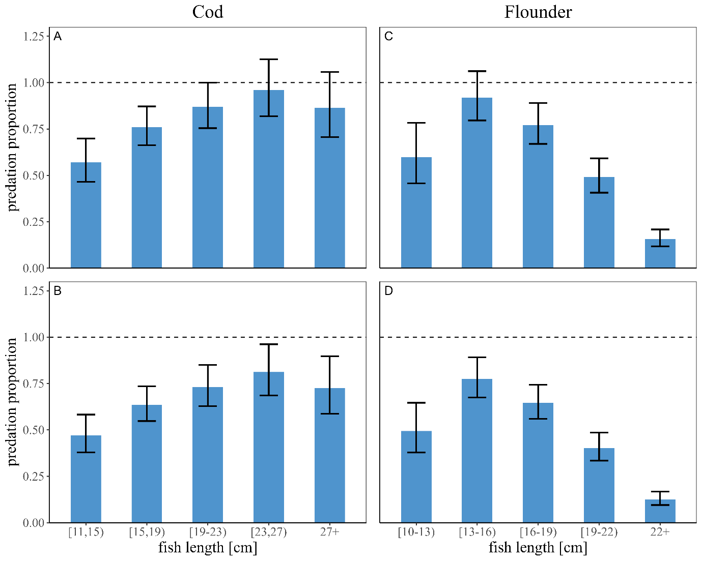
Figure YY1. Estimated predation proportions in relation to size for cod (A and B) and flounder (C and D). A and C are for 2022 and B and D are for 2024. Errorbars indicate $±$ 1 standard deviation on log-scale.
Throughout our whole experiment, we estimate the average predation proportion of cormorant on cod to reach 88.3 % for the most vulnerable size-class, [23,27) cm, followed by the [19,23) and 27+ cm size-classes on 79.7 and 79.2, respectively % (Figure YY2). The lowest average predation proportion on cod was 51.8 % on the smallest size-class, [11,15) cm. Thus, our size-range of cod was not sufficiently wide to establish a lower or upper size limit to cormorant predation. The highest average predation proportion on flounder was 84.4 % on the [13,16) cm size-class, followed by the [16,19) cm size-class, 70,6 % (Figure YY2). The 22+ cm size-class experienced by far the lowest average predation proportion, 14.1 %. The average predation proportion on the smallest flounders, 54.4 %, was not low enough to indicate that we approached the lower size-limit of cormorant predation. However, we did cover the upper size-limit for cormorant predation on flounder, which is somewhere in the mid-twenties cm, and we only recovered 1 out of 155 PIT-tags from flounder >24 cm.

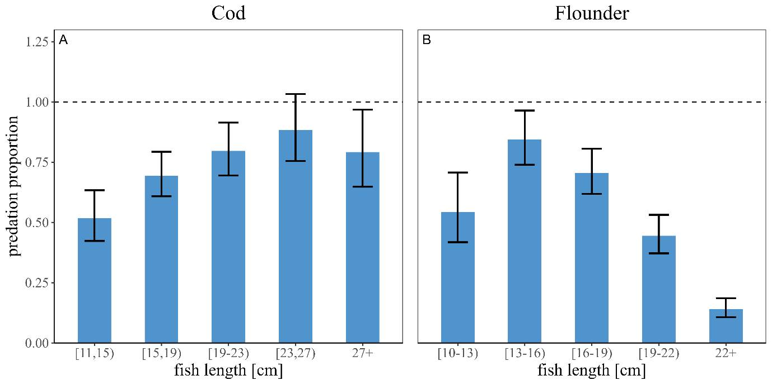
Figure YY2. Estimated average predation proportions in relation to size over the whole experiment for cod (A) and flounder (B). Errorbars indicate $±$ 1 standard deviation on log-scale.

